C++ LENGTH OF LINE PROGRAM LAB REPORT

1) Enter your name, student ID, platform (Mac or PC) and date
Name and Student ID: Jay Gupta, Student ID: 0961979
Class: CIS054 C/C++ Programming
Platform (Mac or PC): PC
Date: 3/19/2020

DESCRIPTION:
Create a program that uses a function to determine the length of a line by inputting the X, Y coordinates of the line endpoints. Show the result with a precision of four decimal places. The function prototype is to be specified as follows:

double lengthOfLine (double X1, double Y1, double X2, double Y2); // returns length of line

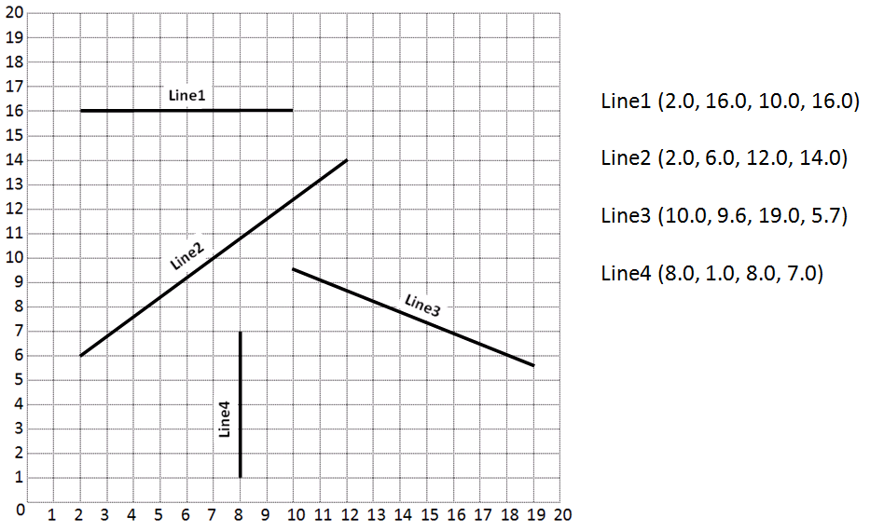

INPUTS | PROCESSING | OUTPUTS
- X1, Y1, X2, Y2 | - Receive values of x1, y1, x2, y2.  - Find the distance between the x values, and the y values.  - Use the Pythagorean Theorem to find the distance between the two points.  - Display the length of the line. | - Length of the line
2) Determine the Inputs, Processing and Outputs before creating the program
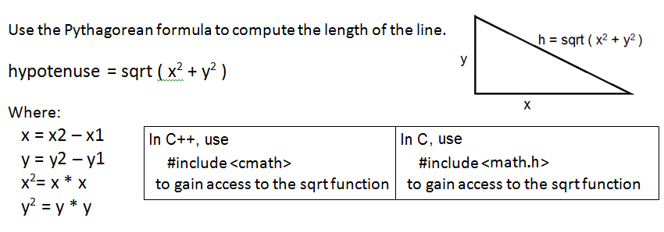

3) Fill in the EXPECTED & ACTUAL RESULTS
TEST DATA VALUES | EXPECTED RESULT  Computed values before the program is run | ACTUAL RESULT  Fill in the output displayed  by the program
2.0 16.0 10.0 16.0 | 8.000 | The length of the line is: 8.0000
2.0 6.0 12.0 14.0 | 12.8062 | The length of the line is: 12.8062
10.0 9.6 19.0 5.7 | 9.8087 | The length of the line is: 9.8087
8.0 1.0 8.0 7.0 | 6.0000 | The length of the line is: 6.0000

DISCUSSION:
4) Complete the DISCUSSION section. It does not need to be long, but it needs to be complete.
4a) What did you do to develop the program? ("Followed the Directions" is not a complete description)

Even though the project description used positive values, I wanted to include the functionality for negative values, if the user wanted to. To do this, I found the absolute value of the difference between the two x values and the two y values. This project, compared to the others, was a bit more on the easy side (I hope I did everything correctly). I simply made the function, did some quick calculations, and outputted the values.

4b) What problems did you have and how did you overcome the problems?

I didn’t have many problems; the only problem I did have was comprehending how ‘cin’ can take in values like it did in this program. In Java, the rules are much stricter, and I believe you can only take in one value at a time. C++ is kind of a weird language; I guess it takes time to get used to.

PROGRAM OUTPUT:
5) Show four screen shots, one for each of the TEST DATA VALUES in the above table.
Refer to previous lab assignments for instructions on how to capture a screen or portions of a screen for either the PC or a Mac.

1.
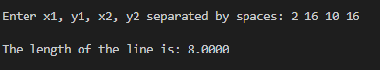

2.
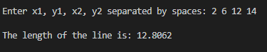

3.
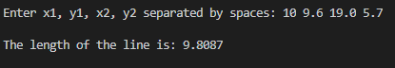

4.
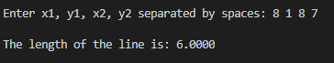
PROGRAM LISTING:
6) Copy and paste the code that YOU typed to make the program work. Your program should include a comment block at the top that shows the name of the program, date, version and your name.

/**
* Name: Jay Gupta
* StudentID: 0961979
* Date: 3/19/2020
* Program Name: C++LengthOfLine.cpp (V1.0)
* CIS054 C/C++ Programming
*
* Inputs: (X1, Y1) and (X2, Y2)
* Outputs: Distance between the two points
*/

#include <iostream> // for cin and cout
#include <cmath> // for sqrt
#include <iomanip> // digits past the decimal
using namespace std;

double lengthOfLine(double x1, double y1, double x2, double y2);

int main() {
double x1, y1, x2, y2, length; // declaring variables

cout << endl << "Enter x1, y1, x2, y2 separated by spaces: ";
cin >> x1 >> y1 >> x2 >> y2;
length = lengthOfLine(x1, y1, x2, y2);

cout << fixed;
cout << setprecision(4);
cout << endl << "The length of the line is: " << length << endl << endl;

return 0;
}

double lengthOfLine(double x1, double y1, double x2, double y2) {
// find distance between two values: absolute value of their difference

double xDistance = abs(x1 - x2);
double yDistance = abs(y1 - y2);

double lineLength = sqrt(xDistance * xDistance + yDistance * yDistance);

return lineLength;
}

